Software: Application Software
sw_applications.php — Software
Quotes….

After ten years of word processing, I can't even do hand writing anymore.
– Douglas AdamsPhoto by Douglas_adams_portrait.jpg: michael hughes from berlin, germanyderivative work: Beao (Douglas_adams_portrait.jpg) [CC BY-SA 2.0 ], via Wikimedia Commons

The downside of word processing - it's quite possible to never end a work-in-progress. Jim Starlin
– Jim StarlinBy Kim Scarborough [CC BY-SA 2.5 ], from Wikimedia Commons

Editing is now the easiest thing on earth to do, and all the things that evolved out of word processing - 'Oh, let's put that sentence there, let's get rid of this' - have become commonplace in films and music too.
– Brian EnoBy cosciansky (originally posted to Flickr as Life of Brian) [CC BY 2.0 ], via Wikimedia Commons

The word processor is a better tool than a quill pen because you can do so much more with it, but on the other hand, what you have to say and how you say it is the ultimate determination.
– Walter MurchBy Beatrice Murch (https://www.flickr.com/photos/blmurch/3125280264/) [CC BY 2.0 ], via Wikimedia Commons

The manual for WordStar, the most popular word-processing program, is 400 pages thick. To write a novel, you have to read a novel - one that reads like a mystery to most people. They're not going to learn slash q-z any more than they're going to learn Morse code. That is what Macintosh is all about.
– Steve JobsPhoto by Matthew Yohe [CC BY-SA 3.0 or GFDL], via Wikimedia Commons
When the simple word processors came in, writing became crisper, less dense - just because of the way we could instantly edit on the screen. Now the ability to mash up words and pictures and links and songs and tweets is what matters. I can't imagine what writing will be like in 2154.
– Gail Collins

Put your goals on paper, or an Excel spreadsheet. Measure every day, 'Did I do my best to...?' Your problems won't disappear, but you will exist in a different relation to them, and you will improve.
– Marshall GoldsmithBy PipMan12345 [CC BY-SA 4.0 ], from Wikimedia Commons

I come from Wall Street, and you'll never see me do a PowerPoint because I'm all about Excel spreadsheets. If it's not in the numbers, I don't care how strategic it is; it doesn't play out.
– Safra A. CatzBy Ilan Costica [CC BY-SA 3.0 or GFDL], from Wikimedia Commons
I love spreadsheets. I do all the finances. I pay the publicists. I have to compartmentalize the creative and the business, so there are sacrifices. But ultimately, I get to be the CEO of my own business.
– Verite

There's something that happens with the collection of a large amount of data when it's dumped into an Excel spreadsheet or put into a pie chart. You run the risk of completely missing what it's about.
– Aaron KoblinBy Chris Milk (Artist) [CC BY-SA 4.0 ], via Wikimedia Commons

The most used program in computers and education is PowerPoint. What are you learning about the nature of the medium by knowing how do to a great PowerPoint presentation? Nothing.
– Sherry Turkle Photo by jeanbaptisteparis on Flikr

I was home-schooled, was always very close with my mom, and was very straight-laced and square. I was never the rebellious one, and I never threw hissy fits. I was the type of person that would show a Powerpoint presentation about why I should do something versus crying and screaming over it.
– Brie LarsonBy Dick Thomas Johnson from Tokyo, Japan [CC BY 2.0 ], via Wikimedia Commons

We have met the Devil of Information Overload and his impish underlings, the computer virus, the busy signal, the dead link, and the PowerPoint presentation.
– James GleickBy JGleick [CC BY-SA 4.0 ], from Wikimedia Commons

It is sad that so many designers don't know how to make. CAD software can make a bad design look palatable! It is sad that four years can be spent on a 3D design course without making anything! People who are great at designing and making have a great advantage.
– Jonathan IveBy Marcus Daweshttp://www.marcusdawes.commarcus@marcusdawes.com (Contact us/Photo submission) [CC BY-SA 3.0 or Attribution], via Wikimedia Commons
I think by drawing, so I'll draw or diagram everything from a piece of furniture to a stage gesture. I understand things best when they're in graphics, not words.
– Robert Wilson

If you need to do a movie where you have an army of 10,000 soldiers, that's a very difficult thing to shoot for real. It's very expensive, but as computer graphics techniques make that cheaper, it'll be more possible to make pictures on an epic scale, which we haven't really seen since the '50s and '60s.
– John KnollBy Star Wars (Seth Green & John Knoll) [CC BY 2.0 ], via Wikimedia Commons

Every age has its storytelling form, and video gaming is a huge part of our culture. You can ignore or embrace video games and imbue them with the best artistic quality. People are enthralled with video games in the same way as other people love the cinema or theatre.
– Andy SerkisGage Skidmore [CC BY-SA 3.0 ], from Wikimedia Commons

Education should learn from the positive side of gaming - reward, accomplishment, and fun.
– Sebastian ThrunBy World Economic Forum (Flickr: Future transportation: Sebastian Thrun) [CC BY-SA 2.0 ], via Wikimedia Commons
If gaming were seen as an art, the important question would be not whether games are good for us but whether they are good, full stop.
– Naomi Alderman

Looking ahead, we see the popularity of eSports exploding as competitive gaming becomes more mainstream and eSports leagues like 'Call of Duty' World League and Overwatch League driving greater engagement and viewership.
– Bobby KotickBy Bobby Kotick [CC BY-SA 2.0 ], via Wikimedia Commons

I was like, 'I want us to stop using that term. I'm not a 'girl gamer.' I'm just a gamer.' The reasons I love gaming are the same reasons everyone loves gaming.
– Aisha TylerBy Gage Skidmore [CC BY-SA 2.0 ], via Wikimedia Commons

Applications Software
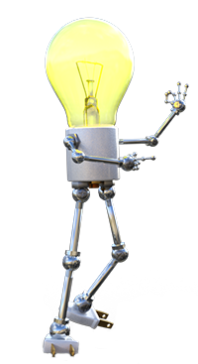

Getting things done!
Applications software is about empowering you - the user - to get things done.
Applications software is where you spend most of your time and effort when working with a computing device.
It's almost possible to say that the more time you have to spend managing the computer and configuring the OS, the less successful the OS is. The OS should, to misquote the popular song - be "the wind beneath the wings" of the applications - invisible, unseen and unused'.
When you learn to use a computer, you ultimately end up learning specific applications software developed to let you do the work you want to do!
Find out more about Applications software in the dropdown below:
What is Applications Software?

Software that focusses on letting you get stuff done
Applications Software is all the software that is used:
to perform productivity tasks (e.g. create and edit documents, spreadsheets and presentations, create graphics and media, design houses, etc.)
to communicate with people
to let you entertain yourself (consume media, play games)
to control machinery and equipment (e.g. POS, factory control systems) and
allow you to combine and share data between multiple applications to accomplish complex tasks.
Generally speaking - applications software is a whole set of software from different companies that allows you to get almost anything done!
In this course you will mainly learn about applications software in theory - most of your practical work will be done in programming (i.e. Systems software).
Back to the top of the Dropdown List
General (office) Productivity Software

The most used software in the world
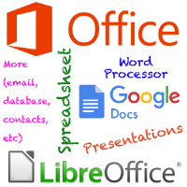
This section is specifically about the three most common types of productivity software, namely:
Word Processors,
Spreadsheet software and
Presentation software.
Word Processors
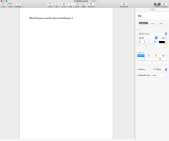
A Word Processor is software designed and developed for creating, editing, formatting and layout of text documents.
Examples of Word Processing applications include:
- Microsoft Word (proprietary / subscription software, Microsoft Corporation)
- Google Docs (Freeware / Subscription)
- LibreOffice Writer (OSS)
- OpenOffice Writer (OSS)
- Apple's Pages (Freeware on Apple hardware)
Typically a word processor is used to create and edit formal documentation - contracts, proposals, CVs, reports, papers, formal letters for posting, books, etc.
One consequence of Word Processing software is that the 'typing pool' - a large group of typists in an office - vanished. Most people (except perhaps top level executives) are expected to be able to use a word processor to create / edit documents themselves.

Word Processing File Types
- Doc / Docx - Microsoft Word
- Pages - Apple Pages
- Odt - OpenOffice Writer / LibreOffice Writer
- Txt - plain text file (no formatting)
- Rtf - Rich text file (basic formatting)
Back to the top of this Panel
Presentation Software
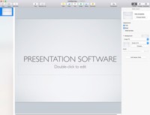
Presentation Software is designed and developed for creating, editing, formatting, layout and presentation of slides of information including graphics, animation, sound and video.
Examples of Presentation Software applications:
- Microsoft Powerpoint (proprietary / subscription software, Microsoft Corporation)
- Google Slides (Freeware / Subscription)
- LibreOffice Impress (OSS)
- OpenOffice Impress (OSS)
- Apple's Keynote (Freeware on Apple hardware)
Presentation software and an LED / LCD projector has replaced more old fashioned presentation technology such as slide shows & overhead projectors. It is used in board rooms, churches, lecture halls and classrooms. In business a presentation is often called a 'deck' (as in a deck of slides).
Presentation software has become a bit of a cliche and a problem. People use it without understanding how to give a good presentation (i.e. they put too much text on a slide, the text says exactly what they say, graphics do not match the content, colour schemes and fonts are poorly designed, etc.). This is why the term 'Death by PowerPoint' is often used in business circles.

Presentation Software File Types
- Ppt / Pptx / Pps - Microsoft PowerPoint
- Key - Apple Keynote
- Odp - OpenOffice Impress / LibreOffice Impress
Back to the top of this Panel
Spreadsheet Software
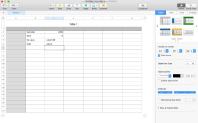
A Spreadsheet is software designed and developed for creating, editing, formatting, calculating, graphing and layout of tables of numbers.
The magic of spreadsheet software is its abstraction and use of formulas. This allows the user to type numbers into parts of the grid and use formulas to use that data to perform calculations. The formulas recalculate themselves whenever new data is entered / data is edited. Graphs based on this data also automatically redraw themselves as the data changes.
Examples of Spreadsheet Software applications:
- Microsoft Excel (proprietary / subscription software, Microsoft Corporation)
- Google Sheets (Freeware / Subscription)
- LibreOffice Calc (OSS)
- OpenOffice Calc (OSS)
- Apple's Numbers (Freeware on Apple hardware)
Typically spreadsheets are used for any type of calculation, statistical analysis, budgets, 'what if' scenarios, creation of graphs and charts, etc.
Spreadsheets are perhaps the office productivity app that save the most amount of time and effort. Before spreadsheets calculations used to have to be done on paper - by hand or using a calculator. Just constructing a simple budget could take weeks of work, often by many people.

Spreadsheet Software File Types
- Xls / Xlsx - Microsoft Excel
- Num - Apple Numbers
- Ods - OpenOffice Writer / LibreOffice Writer
- Csv
Comma Separated Values - text file (no formatting) - used for export / import and data exchange.
Back to the top of this Panel
Software Suites
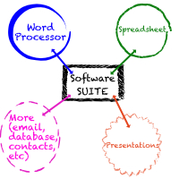
A Suite is simply when multiple productivity apps from a single company are grouped together and made available / sold as a single product.
This allows the developer to charge less than if you bought the products individually.
The developer also tries to make sure that the different apps can work together - i.e. can easily use each other's data (import and export, copy and paste, etc).
Examples of Suites include:
- Microsoft Office / Office 365 (proprietary / subscription software, Microsoft Corporation)
- Google Docs / Google G Suite (Freeware / Subscription)
- LibreOffice (OSS)
- OpenOffice(OSS)
Back to the top of this Panel
Back to the top of the Dropdown List
Databases

The power behind computers
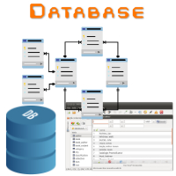
A database is a collection of data and software used to collect, store, process and output the data.
Databases come in many types and scales. Generally speaking they are the 'wind beneath the wings' of most computing software.
The contacts list on your phone? A Database. The list of emails in your email program? A Database. The information on your facebook page? A Database. You probably get the idea…
Databases come in two forms:
Desktop database
Software that is designed to run on a user's computer and works best with a single user but can cope with a low number of users connecting to it over the network.
Examples include:
- Microsoft Access (Proprietary, can be included in Office)
- LibreOffice Base (OSS)
- OpenOffice Base (OSS)
- Filemaker Pro (Proprietary)
- SQLLite (OSS)
Client-Server database (usually called a DBMS or Database Management System).
This is software that runs on a server and manages a database that users can only connect to over the network. It is designed to allow multiple users access to the data at once.
Examples include:
- MySql (OSS)
- Microsoft SQL Server (Proprietary)
- Oracle database (Proprietary)
- and many, many more.
Back to the top of the Dropdown List
Web Design & DTP

Getting information to people
Web Design and DTP (Desktop Publishing) are grouped together because they both involve making information available to others.

Web Design
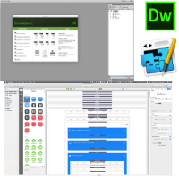
Web design is a complex project. It involves using multiple software tools and skills.
- Content has to be written by someone with writing skills (often done on a word processor)
- Illustrations / photos / animations / videos have to be created / taken by people with the appropriate skills (done using various graphics and illustration software)
- The layout of the publication is created by a designer (using graphics software).
- All of this has to be formatted using HTML and CSS.
- If interactivity is required then a programmer has to write JavaScript to add this feature.
- If the site is dynamic (i.e. the content is generated as needed by the server) then you need someone capable in programming in a language for the server (PHP, Perl, Ruby or JavaScript) AND someone to create, manage and query the database that the content is obtained from.
There is no single tool that allows anyone to create anything beyond a basic web site.
Web site creation software includes:
- Text editing software (preferably a text editor with syntax highlighting and auto-complete - e.g. Sublime Text),
- Adobe DreamWeaver (Proprietary, Subscription only),
- Rapidweaver (Proprietary, Mac only),
- and Online tools such as
- SquareSpace
- Wix
- Wordpress
As you can imagine from the list above, creating a web site is definitely NOT a WYSIWYG process.

Web design file types
Html / Htm
A document containing HTML tags for defining the structure of a web page and containing the content of a web page. This document links to CSS files for formatting, image / video / sound files for media and Javascript files for interactivity.
Css
A file containing the styling information for a HTML document - the CSS code specifies fonts, colours, backgrounds, borders, position on screen and even animation.
Dreamweaver does not have a specific file type. It creates a folder for your web site and everything inside that folder and its subfolders is part of your web site.
Rw
A Rapidweaver file for a web site created in Rapidweaver. Must be exported / 'published' to a server to create a web site.
Js
A JavaScript file containing program instructions executed inside your browser to add interactivity to a web page.
Php
An HTML document containing programming instructions in PHP that will be executed on the server. Can also be a file of just plain PHP programming code.
Online tools do not have a file type visible to the user - your site's data and files are all stored online.
DTP

DTP (Desktop Publishing)
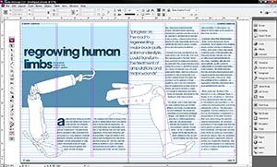
Indesign screenshot from My name is Mike (Flikr)
Publishing
software is used to design and lay out books, magazines, newspapers, newsletters, brochures, etc.
Publishing is a complex project. It involves using multiple software tools and skills.
- Content has to be written by someone with writing skills (often done on a word processor)
- Illustrations / photos have to be created / taken by people with the appropriate skills (done using various graphics and illustration software)
- The layout of the publication is created by a designer (using DTP software).
Examples of publishing software include:
- Adobe Indesign (Proprietary, Subscription only)
- Affinity Publisher (Proprietary)
- Microsoft Publisher (Proprietary)
Creating something with publishing software is a
WYSIWYG
(What You See Is What You Get) process. The layout you create on your screen is what appears on the printed page.

DTP File Types
Indd
- Adobe Indesign
Pub
- Microsoft Publisher
Back to the top of the Dropdown List
Graphics and 3D software

Tools to create our visual world
We live in a visual world - graphics, photos, videos, icons, illustrations are everywhere.
Many (if not most) 0f these images are created, edited or manipulated using some form of software.
Graphics tools can be broken down into three categories:
Bitmap (pixel) graphics
Bitmap Software
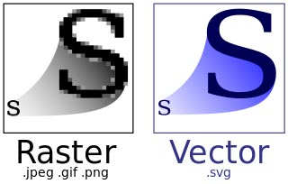
Bitmap images are grids of pixels (image on the left above).
Image By Yug, modifications by 3247 (Unknown) [CC BY-SA 2.5 ], via Wikimedia Commons
Bitmap graphics software is software used to create and edit images that are made up of a grid of pixels.
Examples of Bitmap graphics applications include:
- Adobe Photoshop (proprietary / subscription software, Adobe Corporation)
- The Gimp (OSS)
- Affinity Photo (Proprietary)
- Corel PhotoPaint (Proprietary)
Typically Bitmap graphics software is used to create and edit drawings, paintings, illustrations, etc. It is also used to edit and retouch photographs and prepare bitmap images for their destination (e.g. make sure they are the right size, have the right colour profile, etc.).

Bitmap File types
- Jpg / jpeg
A standard created by the Joint Photographic Experts Group (hence the name). A lossy compressed image - most common bitmap file type popular because of its small size. Cannot contain transparency.
- PNG
Portable Network Graphics. A lossless compressed image. Larger than jpg files but can contain transparency.
- Gif
Graphics Interchange Format. Can only contain 8 bit colour images. Can contain animation.
- PSD
A Photoshop document - can contain multiple layers of graphics elements, transparency, text. File sizes are large. Usually needs to be exported into more common formats to be used.

Images always lie…
Not too long ago people always trusted photographs people believed that 'The Camera NEVER Lies'.
The power of image editing software means that you have to start out with the opposite belief today - first think the image is a lie, and only after there is proof that it has not been altered in some way can you trust it!
A tool that you can use to test an image (especially the latest viral image) is
FotoForensics
- simply upload the image file (preferably a hi res copy) and wait for the verdict…
This is especially true of pictures of models and celebrities - the result of all this image retouching and 'photoshopping' is that we have a distorted and unrealistic view of what beauty is and what the 'perfect' person should look like.
Some of the videos in the links show just how much photoshop work is done on beauty models…
What is a Bitmap?
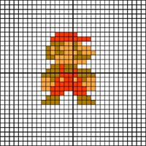

What is a Bitmap image?
A bitmap is a two dimensional grid (like a table).
The first computer images were only two colour - light or dark / black or white.
To create an image some blocks of the grid were filled in (light on the screen) whilst other blocks were left dark.
Each block could then be represented by a bit (a 1 or a 0). That is where the name bitmap comes from.
Nothing much has changed today except the amount of data used to represent each block in the grid.
An 8 bit image allow each block to be one of 255 colours. Each block in the grid is represented by a byte of data.
A 32 bit image allows each block to be one of billions of colours - and have a level of transparency. Each block in the grid is represented by 4 bytes of data.
Notes on Bitmaps
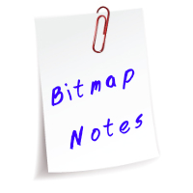

Notes on bitmaps
Bitmaps do not scale well
This means that if you enlarge a bitmap image it gets blocky and pixelated. If you shrink a bitmap it loses detail.
Bitmaps are large files
Even with compression, a bitmap image tends to be a large file. When using a bitmap in your document / on a web page it is always a good idea to work out the size the image needs to be beforehand (pixels wide / pixels high or cm wide / cm high) and then re-size your bitmap image to these dimensions. This prevents unexpected surprises if your image is too small and ends up looking nasty and pixelated - or wasting storage space / bandwidth by using a too large image when a smaller one would do.
Lossy vs Lossless compression.
Lossy compression loses detail in the image each time you save it. This is because lossy compression works out averages of colours in blocks and saves these averages along with a formula for rebuilding the image. The lower the quality setting on the compression (e.g. 50 % jpg) the bigger the block size used for averaging and the more detail lost in the image.
Losless compression keeps track of repeated colours and saves the repeat count and colour - this means the compression is less effective but no detail is lost in the image.
Back to the top of this Panel
Vector graphics
Vector graphics are mathematical formulas and so are sharp at any resolution (image on the right).
Image By Yug, modifications by 3247 (Unknown) [CC BY-SA 2.5 ], via Wikimedia Commons
Vector Graphics are made up of lines, curves, shapes and fills. The data is stored as mathematical formulas.
Vector graphics software is used to create illustrations and diagrams. File sizes are small and the resulting images can be scaled to any size without any loss of quality.
Examples of Vector Graphics Software applications:
- Adobe Illustrator (proprietary / subscription software, Adobe Corporation)
- Corel Draw (Proprietary, PC only)
- Affinity Designer (Proprietary)
- LibreOffice Draw (OSS)
- OpenOffice Draw (OSS)
Whilst Vector graphics tools are used to create illustrations, their file formats are not supported by many other types of software. This is why you seldom see vector image files - they are used by the illustrators and then the final product is exported as a bitmap image (usually jpg or png) for use in the document / presentation or web page it was created for.

Vector Graphics File Types
- Ai - Adobe Illustrator
- Cdr - Corel Draw
- afDesign - Affinity Designer
- Odg - OpenOffice Draw / LibreOffice Draw
- Svg
Scalable Vector Graphics - plain text file used for import and export to exchange data between vector graphics apps. Web browsers can display SVG graphics and use of this file format on the web is increasing.
- Eps - Encapsulated PostScript - another common import / export and data exchange file type.
- Pdf - Portable Document Format. This file type can be used to import / export vector graphics as well.
Back to the top of this Panel
3D Graphics
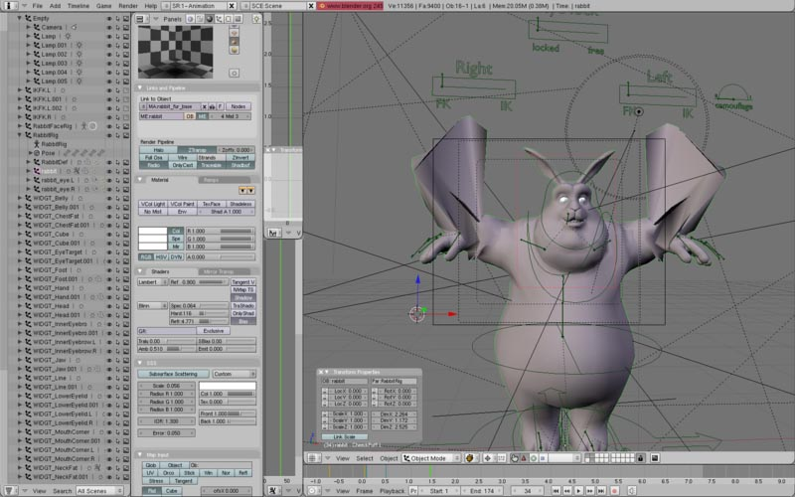
Screenshot of a character being worked on in Blender.
By Floyd Wilde (originally posted to Flickr as Screenshot-Blender) [CC BY-SA 2.0 ], via Wikimedia Commons
3D graphics are 'models' consisting of lines and polygons drawn in a 3D space and represented by mathematical formulas.
The surfaces of these models are then covered with textures made up of either bitmap images or mathematically generated formulas. Textures have maths formulas describing how reflective they are, how they interact with light, etc.
The scene is then provided with 'light sources' which are mathematically represented lights (where the light is located, what its strength is, what its colour is, etc).
The scene finally gets a mathematical 'camera' which is the view that will be generated of the scene (what angle you are looking at the scene at, how sensitive the 'camera' is to light, how wide the lens is, what it is focussed on, etc).
To create an image the 3D scene has to be rendered as viewed by a camera. The software constructs the models, applies the textures, shines the light on the textures and traces how that light bounces off the object and enters the 'camera'.
The rendering process for a 3D image can take hours, days or even weeks - depending on how complex the 3D scene is.
3D scenes for films are often rendered by groups of computers working simultaneously on all the maths to generate just one frame of the film at a time.
Examples of 3D Graphics Software applications:
- Maya / 3DS Max (Proprietary / subscription software - PC only, AutoDesk corporation)
- Cinema 4D (Proprietary)
- zBrush (Proprietary)
- Blender (OSS)
- Daz 3D (Proprietary, Freeware)
3D graphics software can be used to generate still images, but is most often used to create the elements (characters, objects, landscapes) used in 3D games - and all the special effects you see in TV and video.
Take a moment here to understand why games need such powerful computers - all of the 3D characters, objects and landscapes have to be rendered in real time, responding to what is happening in the game - often at rates of at minimum 60 frames per second (i.e. the computer has to render 60 images in a second). On top of this the computer still has to manage its own characters using AI and keep track of what you (the user) are doing!
Special versions of 3D software such as
SolidWorks
is specifically used in engineering.
You virtually never see 3D graphics file formats because they are used by the creators and then exported as movies or graphical images.

Computing requirements
As you can imagine from all the mathematics involved in creating a 3D image, 3D Graphics requires a powerful computer with multiple cores, a large amount of memory and a good GPU.
NB: Many 3D Graphics programs use the GPU to help with the maths in the rendering process - but often they only support nVidia's graphics cards with their CUDA API.
Back to the top of this Panel
Back to the top of the Dropdown List
Media - Audio, Video & Animation

How your entertainment is made
Virtually all media that you encounter has been created or edited using some form of software.
We will briefly touch on some of the concepts and tools in the three main sections of interest, namely:
Video Editing
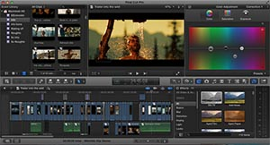
Video is edited on a timeline - the bottom of the image shows short 'cuts' of video arranged one after the other.
By Bullon94 [CC BY-SA 3.0 ], from Wikimedia Commons
Video editing software is used to edit movies - add cuts, transitions, titles, effects, soundtracks, sound effects and even subtitles to video to create a video advert, film, tutorial or TV show.
Video is captured using a film camera or a digital video camera (which includes smartphones and webcams). If film was used, the video is scanned. If a digital camera was used the files are transferred from the camera / copied from the memory card used in the camera.
The video is imported into the video editing software along with other resources (music, sound effects, etc).
The video, effects, titles, transitions, etc are all arranged on a timeline by the editor to create the finished video product.
Finally the video is exported (during which it is compressed) to make a file viewable by the end user.
Examples of video editing software include:
- Adobe Premiere Pro (proprietary / subscription software, Adobe Corporation)
- Final Cut Pro X (Proprietary, Mac only, Apple)
- Avid Media Composer (Proprietary, Subscription)
- BlackMagic DaVici Resolve (Proprietary, Free version & full featured paid version)
There are many other, cheaper video editing tools out there (
iMovie
(Proprietary, Mac only, Apple, Free with Apple hardware),
Corel VideoStudio
,
VEGAS
Pinnacle Studio
and
OpenShot
(OSS) - but the ones mentioned above are the best tools out there).
Usually video editing software focusses on creating and editing the timeline. Effects and transitions are created and managed using separate software (for Adobe this is
After Effects
, for Apple this is
Motion
).
Most of the more powerful video editing tools have their own API and have a large range of plugins available that add more features, titles and special effects than come with the standard package.
3D graphics software is used to create characters, objects, scenes and effects that are mixed with filmed video in the editing process.

Final Video File types
- Mp4
- Avi
- Mov
- Wmv

Screen Capture
Tutorial videos often show recordings of the screen as someone uses software and explains what they are doing. This is done with software such as
Camtasia
(Proprietary) or
Filmora scrn
(OSS).
The software usually not only allows you to capture the screen but also has editing tools as well.
Back to the top of this Panel
Audio editing and music making
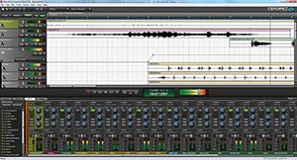
Sound editing software (above) and Music notation software (below) - screenshots in the Public Domain.
Sound editing software is used to record and edit soundtracks for video, create special sound effects, record, create and edit music, etc.
Just like for video editing software there are a large number of sound editing tools available. You can go from the simple voice memo recorder on your smartphone to a full featured sound mixing studio.
Examples of Audio Editing Software applications:
- Adobe Audition (proprietary / subscription software, Adobe Corporation)
- Garage Band (Proprietary, Mac only, Apple, Free with Apple hardware)
- Logic Pro X (Proprietary, Mac only, Apple)
- Pro Tools (Proprietary, Avid, Free version and full featured paid version)
- Audacity (OSS)
You even get full featured composition software that helps you to compose and write music scores - such as Avid's
Sibelius
(Proprietary, Subscription) or
MuseScore
(OSS).
Tools such as
SonicFire Pro
allow you to buy pre-composed music that can be adjusted to fit any length of time and mood.

Final Audio File Types
- Mp3
- Aac
- Ogg
- Wav
- M4a
- Flac
Back to the top of this Panel
Animation
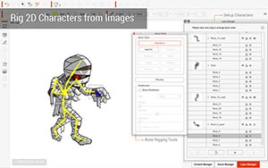
3D Graphics software produces 3D Animation. This software was discussed in the graphics section.
2D Animation is software that allows you to draw and animate vector and bitmap images.
Examples of Animation Software applications:
- Moho Pro (Proprietary)
- CrazyTalk Animator (Proprietary)
- Toon Boom Harmony (Proprietary, Subscription or Purchase)
- Synfig (OSS)
- Pencil2D (OSS)
2D Animation is used for advertising, tutorials, movies and TV shows.
Back to the top of this Panel
Back to the top of the Dropdown List
CAD, Architecture and Engineering

Design, Plan, Execute
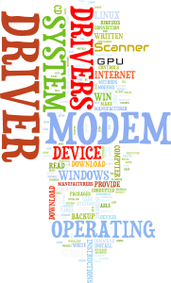
Most things made by humans start with a plan or design - a sketch or drawing.
Before any product is made it is planned in detail with drawings that specify dimensions, materials, etc. This is equally true of a bottle for pills, a bridge, a car, an aeroplane or a house.
CAD (Computer Aided Design) is the general term for the software and process used to create these drawings on a computer.
Examples of CAD software include:
- AutoCAD (Proprietary, Subscription)
- SolidWorks (Proprietary, Subscription / single purchase)
- LibreCAD (OSS)
- FreeCAD (OSS)
CAD software requires relatively powerful hardware - especially for large scale projects (e.g. designing a car, an aeroplane, a bridge, etc.).
Back to the top of the Dropdown List
Financial and Business Software

Follow the money…
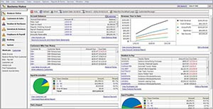
Financial software is used to track and manage money.
There is a vast range of this type of software and much of what it does is technical and requires quite a lot of explanation.
A lot of this software is developed in house or custom written to suit a particular business's needs.
We are not going to discuss this software here - just give you some examples of categories of this type of software.
Types of
Financial
software include:
- Accounting software
- Payroll management
- Inventory and stock control
- POS (Point Of Sales) systems
- Stock (as in stock exchange) trading software
Types of
Business
software include:
- Project Management Software
- CRM (Customer Relationship Management) software
- Production control software
- Logistics management software
- POS (Point Of Sales) systems
Back to the top of the Dropdown List
Maps and Navigation

Our place on the surface of the Earth…
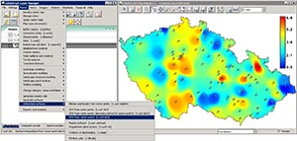
GIS software helps display database information on a map.
We all use GPS today and are used to the power of navigation apps such as
Google Maps
,
Waze
and
Apple maps
as well as dedicated GPS Navigation devices from
Garmin
and
TomTom
.
It is the power of GPS and mapping that makes businesses such as Uber possible.

GIS - where the real power is
BUT… mapping software is more than GPS and navigation.
GIS (Geographic Information Systems) combine maps and databases to enable better design, planning and management of facilities, cities and countries.
Back to the top of the Dropdown List
Educational software

IT in Education
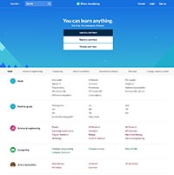
IT is a large part of education - both on the administrative side and on the teaching & learning side of the process.
Schools / Universities use software to track their student enrolment and record their progress. This type of software generates reports, calculates grades, averages and pass / fail status and even attendance.
Educators use IT to prepare lessons, generate materials & media and even to present lessons to their students.
Students use IT to ease their work flow, create work for submission and to do research.

Online education
Increasingly resources for teaching and learning are available online.
YouTube is a great resource for tutorial videos. YouTube needs to be used with caution though - many videos contain inaccuracies and may be outdated or reflect their creator's bias.
Never watch just one video on a topic - watch multiple videos and compare their content. If there is conflicting information, you need to do extra research to find out which information is correct.
Online Encyclopaedias (e.g. Wikipedia) are a common source of information. Many Universities do not accept Wikipedia as a valid source because it is unchecked and unverified information subject to change at any moment by anyone. Bear this in mind when you do your own research - just like with YouTube, Never read just one source on a topic - read multiple sources and compare their content. If there is conflicting information, you need to do extra research to find out which information is correct.

Online Courses
A great free resource to start off with is the
Khan Academy
. They offer lessons in many, many topics for free. Their content is tailored to the American syllabi, but that really only affects the order of presentation…
Many universities provide free access to their course material online, for example
MIT Open Courseware
and the UK's
Open University
There are even MOOC (Massive Open Online Courses) avalaible - find out more at
MOOC.org
.
Paid for courses range from mainly video based tutorial sites such as
Lynda.com
and
Pluralsight
(where you pay a monthly subscription and can watch as many video tutorials on any subject you like) to courses offered by sites such as
GetSmarter
- and, of course, the online textbook you are using right now.
Back to the top of the Dropdown List
Games and Gaming

All your base are belong to us!

Gaming ranges from casual games played on your mobile device to kill time to heavy duty competitive multiplayer matches and competitions.
High end games demand high end computers and gamers tend to have the highest specs for computers out of all possible users.

E-sports
Competitive gaming is also known as e-sports.
Teams of gamers compete against each other for massive prizes (sometimes in the millions of USD). These competitions are broadcast on TV or on streaming services such as
Twitch
. Competitors and teams often have their computers (or at least some of their hardware) sponsored by companies.
In 2018 Telkom sponsored the first inter-school competitive gaming tournament held at Comic Con Africa.
Back to the top of the Dropdown List

Video Links - Office Software
We have selected and curated a set of videos on YouTube related to your course.
These videos are not created or owned by us.
They may display advertising and in some cases may contain limited amounts of swearing.

Video Links - Database

Video Links - Web Design

Video Links - DTP
We have selected and curated a set of videos on YouTube related to your course.
These videos are not created or owned by us.
They may display advertising and in some cases may contain limited amounts of swearing.

Video Links - Graphics & 3D

Video Links - Video Editing

Video Links - Audio & Music
We have selected and curated a set of videos on YouTube related to your course.
These videos are not created or owned by us.
They may display advertising and in some cases may contain limited amounts of swearing.

Video Links - Animation

Video Links - Finance and Business

Video Links - Mapping & GPS
We have selected and curated a set of videos on YouTube related to your course.
These videos are not created or owned by us.
They may display advertising and in some cases may contain limited amounts of swearing.

Video Links - Education

Video Links - Gaming

